**Buổi 4: Tìm kiếm trong không gian trạng thái**

Bài 1. Biễu diễn đồ thị

1. Biễu diễn bằng danh sách / ma trận kề

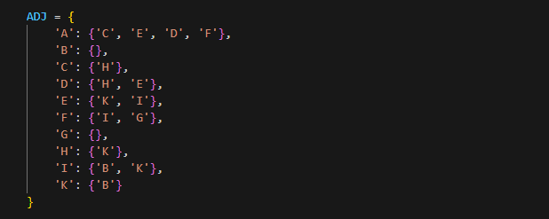

1. Thao tác duyệt đồ thị

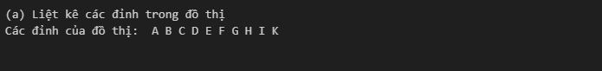

1. Đọc và lưu đồ thị

Bài 2. Tìm kiếm đường đi trên đồ thị

1. Tìm kiếm theo chiều rộng (BFS)

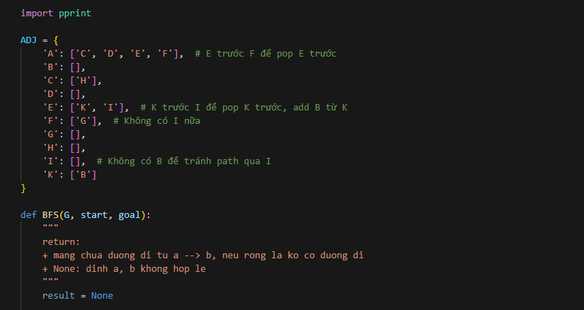



2. Tìm kiếm theo chiều rộng (DFS)

